1. Write a MongoDB query to display all the documents in the collection restaurants

db.resturent.find()

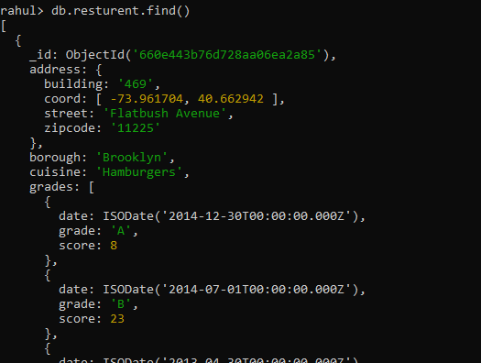

2. Write a MongoDB query to display the fields restaurant_id, name, borough and cuisine for

all the documents in the collection restaurant.

db.resturent.find({},{restaurant_id:1,name:1,cuisine:1,borough:1});

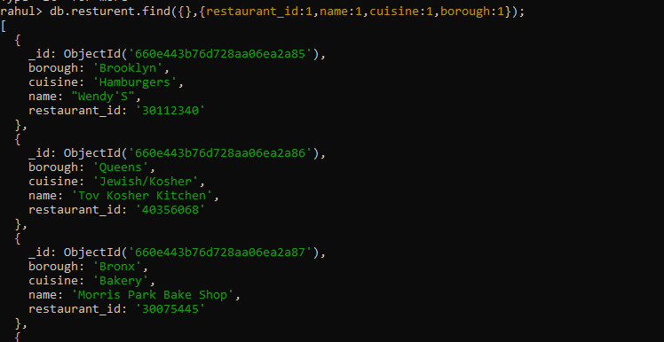

3. Write a MongoDB query to display the fields restaurant_id, name, borough and cuisine,

but exclude the field _id for all the documents in the collection restaurant.

db.resturent.find({}, { _id: 0, restaurent_id: 1, name: 1, cuisine: 1, borough: 1 })

4. Write a MongoDB query to display the fields restaurant_id, name, borough and zip code,

but exclude the field _id for all the documents in the collection restaurant.

db.resturent.find({}, { _id: 0, restaurent_id: 1, name: 1, cuisine: 1, borough: 1,address:{zipcode:1} })

5. Write a MongoDB query to display all the restaurant which is in the borough Bronx

db.resturent.find({borough:'Bronx'})

6. Write a MongoDB query to display the first 5 restaurant which is in the borough Bronx.

db.resturent.find({borough:’Bronx’}).limit(5)

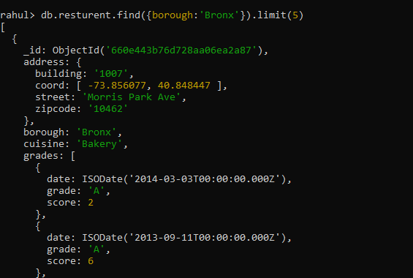

7.Write a MongoDB query to display the next 5 restaurants after skipping first 5 which are in

the borough Bronx.

db.resturent.find({borough:’Bronx’}).skip(5)

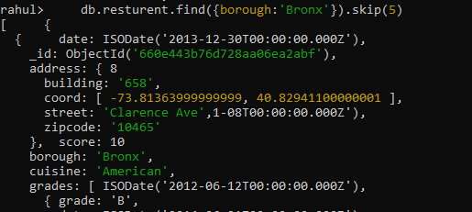

8. Write a MongoDB query to find the restaurants who achieved a score more than 90.

db.resturent.find({‘grades.score’:{$gt:2}}}}});

9. Write a MongoDB query to find the restaurants that achieved a score, more than 80 but

less than 100.

db.resturent.find({“grades.score":{$gt:2,$lt:4}}}},{name:1});

10. Write a MongoDB query to find the restaurants which locate in latitude value less than -

95.754168.\\

db.resturent.find({'address.coord.1':{$lt:95.754168}})

11. Write a MongoDB query to find the restaurants that do not prepare any cuisine of

'American' and their grade score more than 70 and latitude less than -65.754168.

db.resturent.find({$and:[{cuisine:{$not:'American'}},{'grades.score':{$gt:70}},{address:{$lt:-65.}}]})

12. Write a MongoDB query to find the restaurants which do not prepare any cuisine of

'American' and achieved a score more than 70 and located in the longitude less than -

65.754168.

db.resturent.find({$and:[{cuisine:{$not:'American'}},{'grades.score':{$gt:70}},{address:{$lt:-65}}]})

13. Write a MongoDB query to find the restaurants which do not prepare any cuisine of

'American ' and achieved a grade point 'A' not belongs to the borough Brooklyn. The

document must be displayed according to the cuisine in descending order.

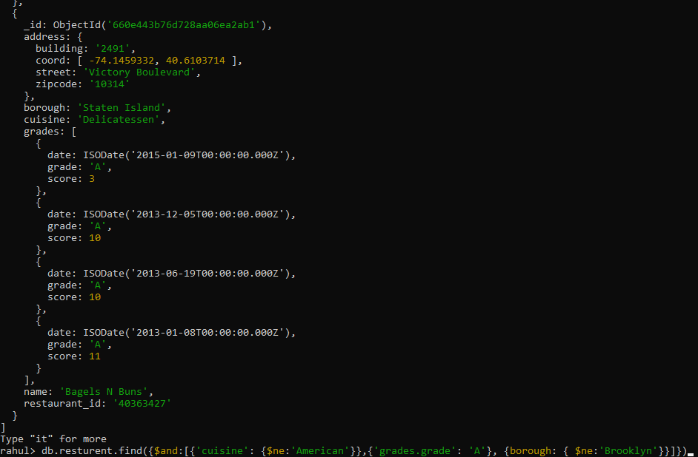

db.resturent.find({$and:[{'cuisine': {$ne:'American'}},{'grades.grade': 'A'}, {borough: { $ne:'Brooklyn'}}]})

.sort(cuisine:-1)

14. Write a MongoDB query to find the restaurant Id, name, borough and cuisine for those

restaurants which contain 'Wil' as first three letters for its name.

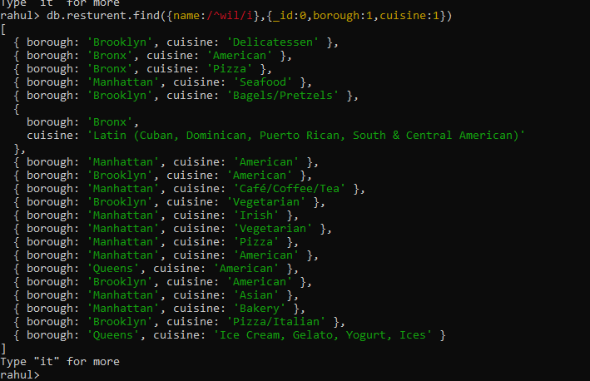

db.resturent.find({name:/^wil/i},{_id:0,borough:1,cuisine:1})

15. Write a MongoDB query to find the restaurant Id, name, borough and cuisine for those

restaurants which contain 'ces' as last three letters for its name.

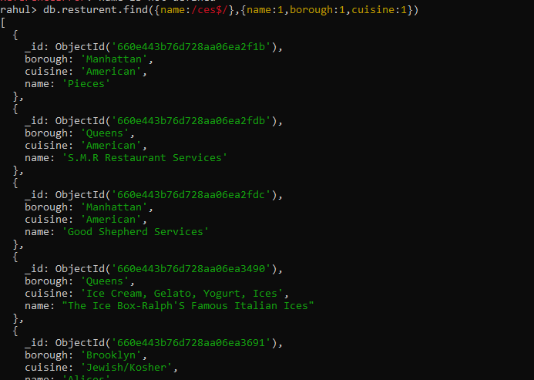

16. Write a MongoDB query to find the restaurant Id, name, borough and cuisine for those

restaurants which contain 'Reg' as three letters somewhere in its name.

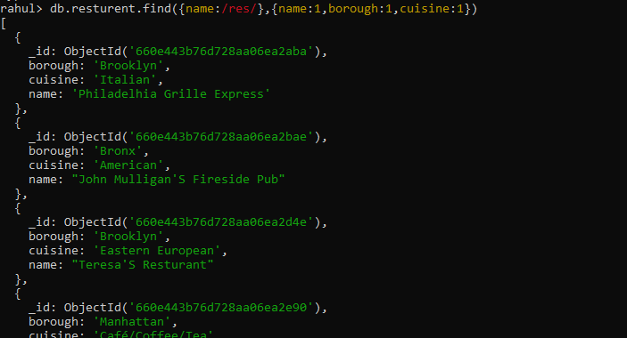

db.resturent.find({name:/res/},{name:1,borough:1,cuisine:1})

17. Write a MongoDB query to find the restaurants which belong to the borough Bronx and

prepared either American or Chinese dish.

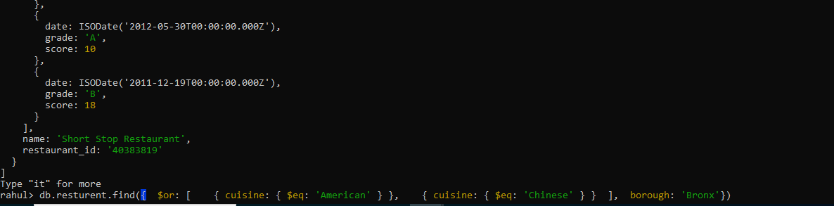

db.restaurants.find({ $or: [ { cuisine: { $eq: 'American' } }, { cuisine: { $eq: 'Chinese' } } ], borough: 'Bronx'})

18. Write a MongoDB query to find the restaurant Id, name, borough and cuisine for those

restaurants which belong to the borough Staten Island or Queens or Bronxor Brooklyn.

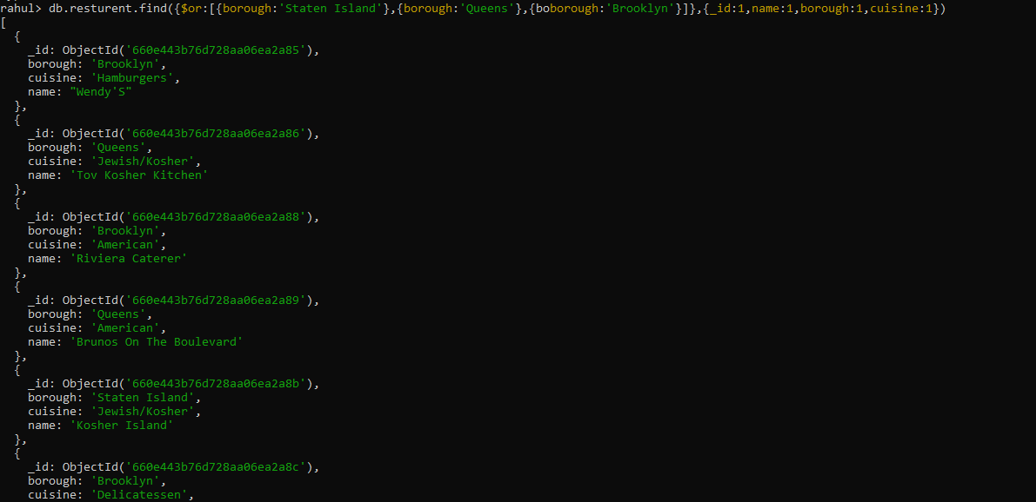

db.resturent.find({$or:[{borough:'Staten Island'},{borough:'Queens'},{borough:'Brooklyn'}]},{_id:1,name:1,borough:1,cuisine:1})

19. Write a MongoDB query to find the restaurant Id, name, borough and cuisine for those

restaurants which are not belonging to the borough Staten Island or Queens or Bronxor

Brooklyn.

db.resturent.find({borough:{$nin:['Staten Island','Queens','Brooklyn']}},{_id:1,name:1,borough:1,cuisine:1})

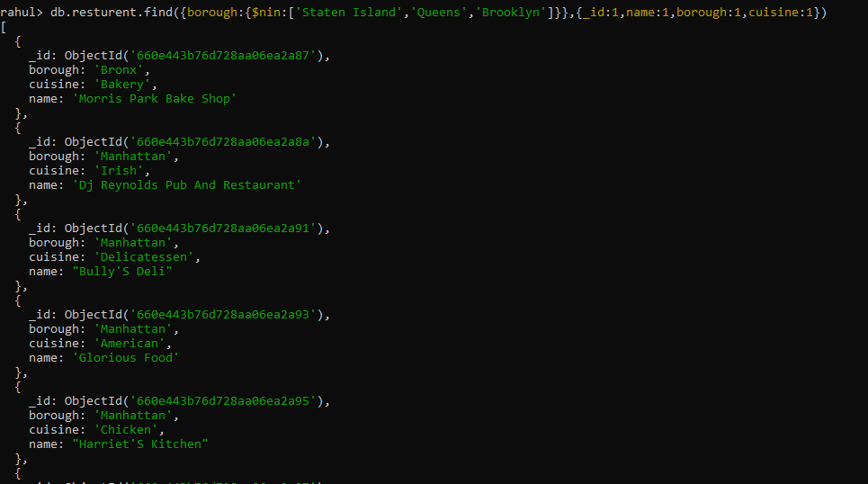

20. Write a MongoDB query to find the restaurant Id, name, borough and cuisine for those

restaurants which achieved a score which is not more than 10.

db.resturent.find({'grades.score':{$lt:10}},{name:1,borough:1,cuisine:1})

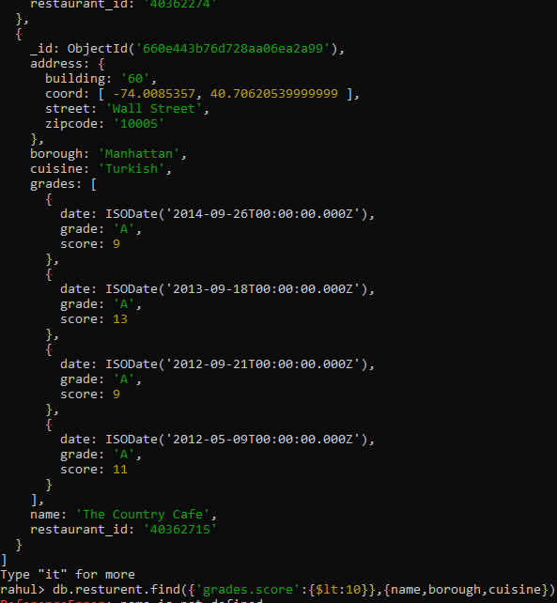

21. Write a MongoDB query to find the restaurant Id, name, borough and cuisine for those

restaurants which prepared dish except 'American' and 'Chinees' or restaurant's name begins

with letter 'Wil'.

db.resturent.find({$or:[{cuisine:{$nin:['American','Chinese']}},{name:/^WIL/i}]},{_id:1,name:1,borough:1,cuisine:1})

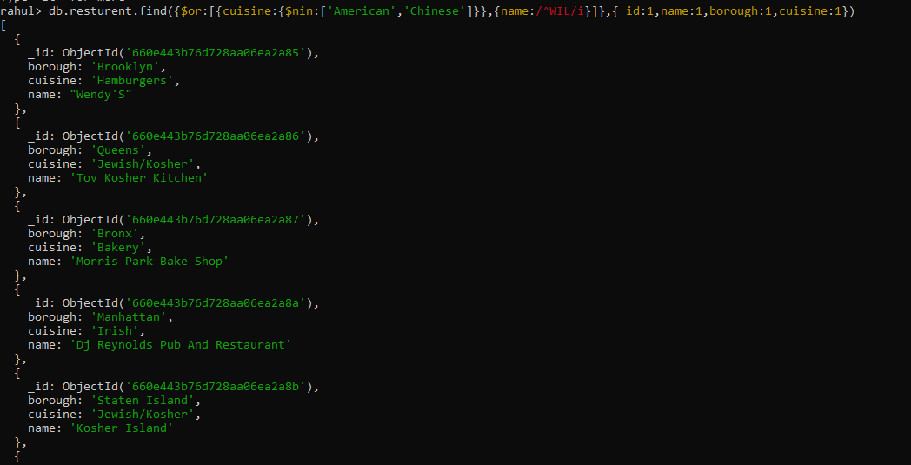

22. Write a MongoDB query to find the restaurant Id, name, and grades for those restaurants

which achieved a grade of "A" and scored 11 on an ISODate "2014-08-11T00:00:00Z"

among many of survey dates

db.resturent.find({grades:{$elemMatch:{date:ISODate("2014-08-11T00:00:00Z"),grade:'A',score:11}}});

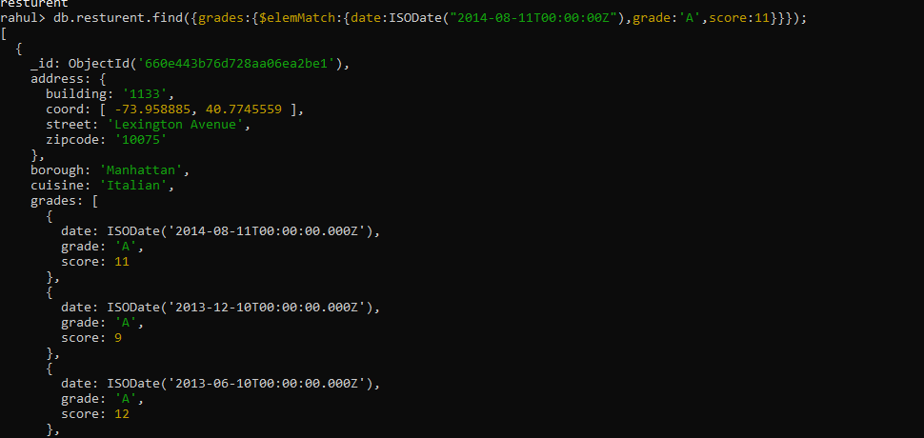

23. Write a MongoDB query to find the restaurant Id, name and grades for those restaurants

where the 2nd element of grades array contains a grade of "A" and score 9 on an ISODate

"2014-08-11T00:00:00Z".

db.resturent.find({'grades.1.date':ISODate("2014-08-11T00:00:00Z"),'grades.1.grade':'A','grades.1.score':9});

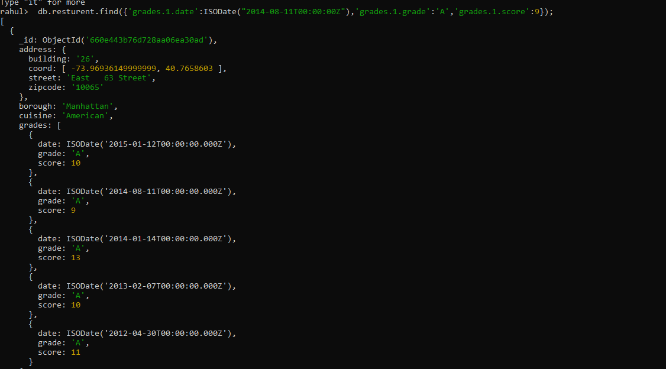

24. Write a MongoDB query to find the restaurant Id, name, address and geographical

location for those restaurants where 2nd element of coord array contains a value which is

more than 42 and upto 52

db.resturent.find({'address.coord.1':{$gt:42,$lt:52}},{_id:1,name:1,'address.coord':1}

)

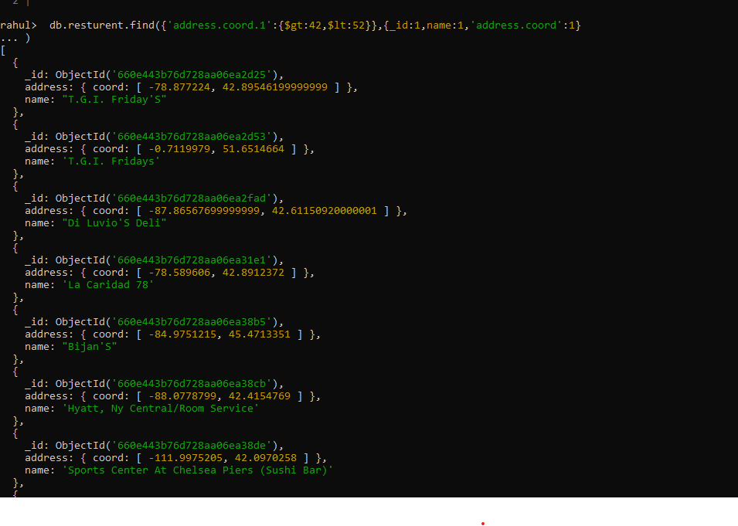

25. Write a MongoDB query to arrange the name of the restaurants in ascending order along

with all the columns.

db.resturent.find().sort({name:1});



26. Write a MongoDB query to arrange the name of the restaurants in descending along with

all the columns.

db.resturent.find().sort({name:-1});

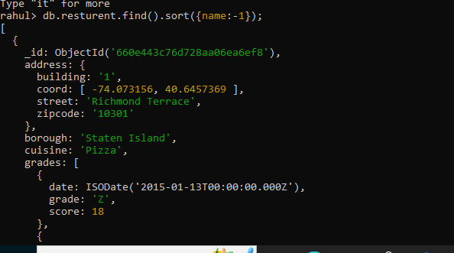

27. Write a MongoDB query to arranged the name of the cuisine in ascending order and for

that same cuisine borough should be in descending order.

db.resturent.find().sort({name:1,borough:-1});

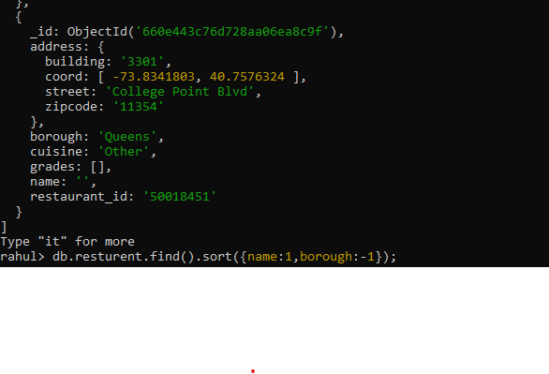

28. Write a MongoDB query to know whether all the addresses contains the street or not.

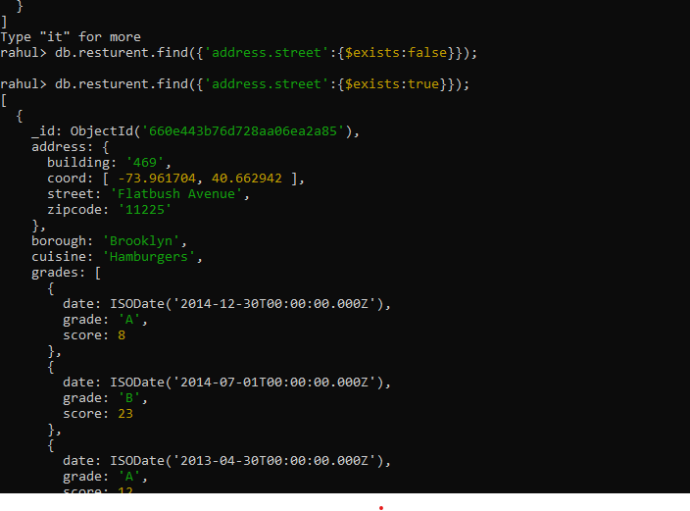

db.resturent.find({'address.street':{$exists:true}});

29. Write a MongoDB query which will select all documents in the restaurants collection

where the coord field value is Double.

db.resturent.find({'address.coord.0':{$type:'double'}})

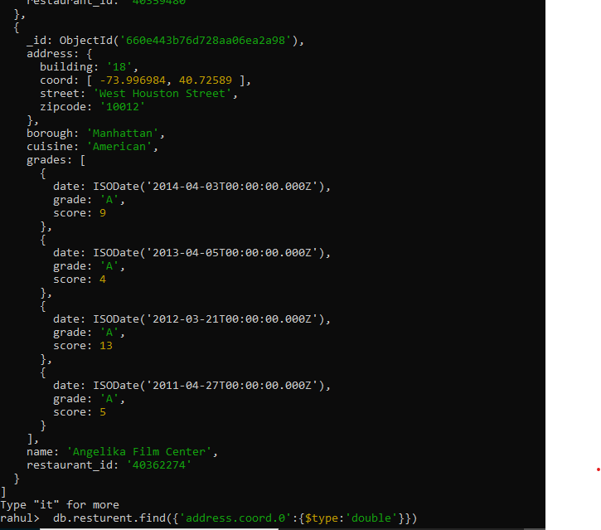

30. Write a MongoDB query which will select the restaurant Id, name and grades for those

restaurants which returns 0 as a remainder after dividing the score by 7.

db.resturent.find({'grades.score':{$mod:[7,0]}},{_id:1,name:1,grades:1})

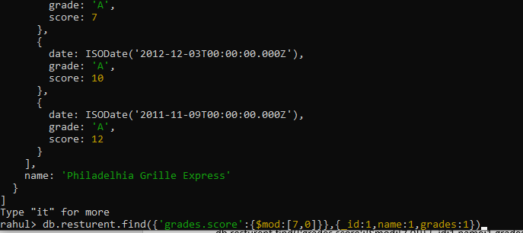

31. Write a MongoDB query to find the restaurant name, borough, longitude and attitude and

cuisine for those restaurants which contains 'mon' as three letters somewhere in its name.

db.resturent.find({name:/^.*mad.*$/i},{_id:1,brough:1,'address.coord.0':1,'address.coord.1':1,cuisine:1,name:1})

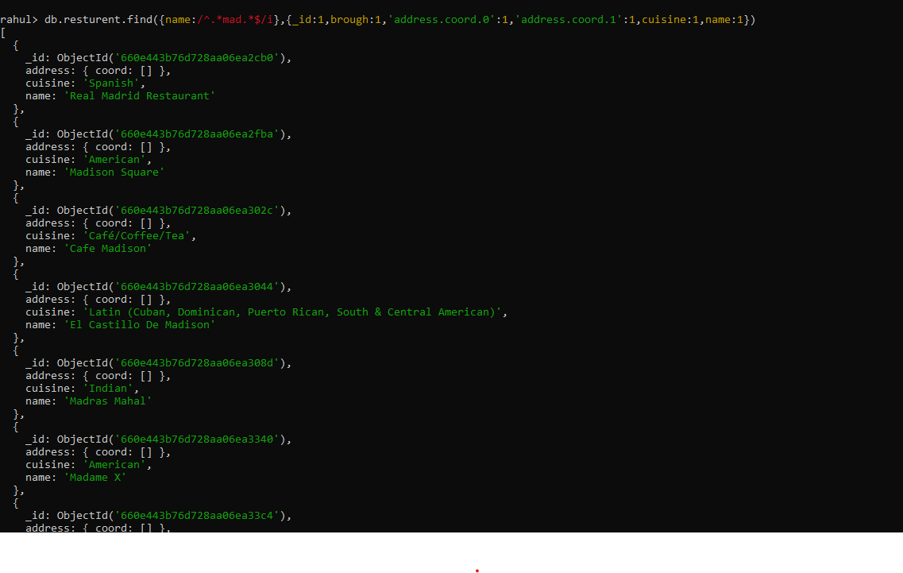

32. Write a MongoDB query to find the restaurant name, borough, longitude and latitude and

cuisine for those restaurants which contain 'Mad' as first three letters of its name.

db.resturent.find({name:/^mad/i},{_id:1,brough:1,'address.coord.0':1,'address.coord.1':1,cuisine:1})

